First principle model draft

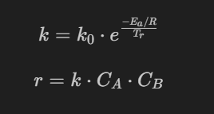

- k is the reaction rate constant, governed by the Arrhenius equation. As the reactor temperature ($T_{r}$) increases, $k$ increases exponentially.
- $k_{0}$ is the pre-exponential factor, and $E_{a}/R$ is the activation energy over the gas constant.
- $r$ is the actual reaction rate, taking into account the constant $k$ and the current concentration of both reactants, $C_{A}$ and $C_{B}$
Volume Balance
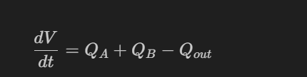
Qout = 35ml/min constant throughout the experiment
Mass Balance
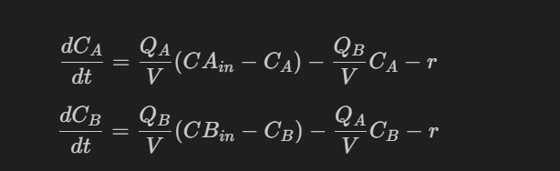

Energy Balance
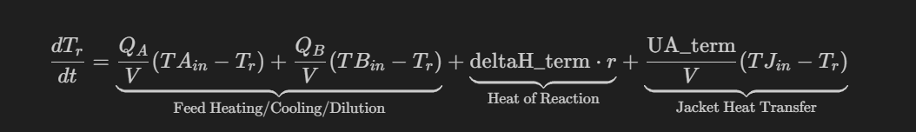

Parameters Being Esitmated
- $k_{0}$ (Pre-exponential factor)
- $ΔH_{term}$ (Heat of Reaction term)
- $UA_{term}$ (Overall Heat Transfer Coefficient term):
- activation energy parameter $E_{a}/R$

